# CA LAB: 10

# TO INTERFACE DC-MOTORS WITH ARDUINO UNO

# Muhammad Usman Hussain 12439

**Diagram:**

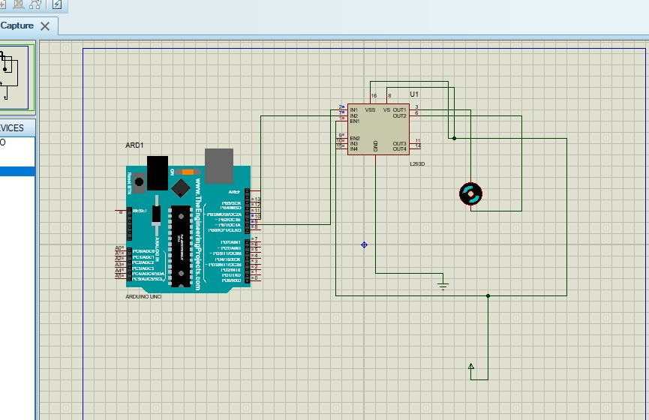

**Code:**

int val =150;

void setup() {

// put your setup code here, to run once:

}

void loop() {

// put your main code here, to run repeatedly:

analogWrite(9,val);

analogWrite(10,0);

delay(10);

}